PROJECT TITLE: WIFI CONTROL CAR

NAME:

1)Eshwar - 12201475 (02)

2)Subba Rao - 12205829 (06)

3)Harish - 12207311 (07)

4)Sibiraj - 12210793 (09)

SECTION : EM303

SUBJECT : INTRODUCTION TO INTERNET OF THINGS(IOT)

SUBJECT CODE : ECE217

SUBMITTED TO : Dr. Someet singh

INTRODUCTION:

In an era where connectivity is paramount, the integration of WiFi technology with everyday devices continues to revolutionize the way we interact with our environment. The WiFi controlled car project embodies this ethos by leveraging the ubiquitous nature of WiFi networks to create a versatile and innovative means of remote vehicle control.

This project aims to construct a remotely controllable car that can be maneuvered via a WiFi connection, allowing users to navigate the vehicle from a distance using a simple interface on their smartphone or computer. By harnessing the power of WiFi, this project not only offers convenience but also opens up possibilities for automation, surveillance, and exploration in various domains such as home automation, security, and education.

Through this endeavor, we delve into the realms of embedded systems, wireless communication, and mobile application development, offering an enriching experience for enthusiasts and learners alike. This document serves as a guide to understanding the construction, implementation, and potential applications of the WiFi controlled car, showcasing the fusion of technology and creativity in modern engineering projects.

# CODE :

﻿// Starting of Program

int m1a = 9;

int m1b = 10;

int m2a = 11;

int m2b = 12;

char val;

void setup()

{

pinMode(m1a, OUTPUT); // Digital pin 10 set as output Pin

pinMode(m1b, OUTPUT); // Digital pin 11 set as output Pin

pinMode(m2a, OUTPUT); // Digital pin 12 set as output Pin

pinMode(m2b, OUTPUT); // Digital pin 13 set as output Pin

Serial.begin(9600);

}

void loop()

{

while (Serial.available() > 0)

{

val = Serial.read();

Serial.println(val);

}

if( val == 'F') // Forward

{

digitalWrite(m1a, HIGH);

digitalWrite(m1b, LOW);

digitalWrite(m2a, HIGH);

digitalWrite(m2b, LOW);

}

else if(val == 'B') // Backward

{

digitalWrite(m1a, LOW);

digitalWrite(m1b, HIGH);

digitalWrite(m2a, LOW);

digitalWrite(m2b, HIGH);

}

else if(val == 'L') //Left

{

digitalWrite(m1a, LOW);

digitalWrite(m1b, LOW);

digitalWrite(m2a, HIGH);

digitalWrite(m2b, LOW);

}

else if(val == 'R') //Right

{

digitalWrite(m1a, HIGH);

digitalWrite(m1b, LOW);

digitalWrite(m2a, LOW);

digitalWrite(m2b, LOW);

}

else if(val == 'S') //Stop

{

digitalWrite(m1a, LOW);

digitalWrite(m1b, LOW);

digitalWrite(m2a, LOW);

digitalWrite(m2b, LOW);

}

else if(val == 'I') //Forward Right

{

digitalWrite(m1a, HIGH);

digitalWrite(m1b, LOW);

digitalWrite(m2a, LOW);

digitalWrite(m2b, LOW);

}

else if(val == 'J') //Backward Right

{

digitalWrite(m1a, LOW);

digitalWrite(m1b, HIGH);

digitalWrite(m2a, LOW);

digitalWrite(m2b, LOW);

}

else if(val == 'G') //Forward Left

{

digitalWrite(m1a, LOW);

digitalWrite(m1b, LOW);

digitalWrite(m2a, HIGH); digitalWrite(m2b, LOW);

}

else if(val == 'H') //Backward Left

{

digitalWrite(m1a, LOW);

digitalWrite(m1b, LOW);

digitalWrite(m2a, LOW);

digitalWrite(m2b, HIGH);

}

}

CIRCUIT DIAGRAM :

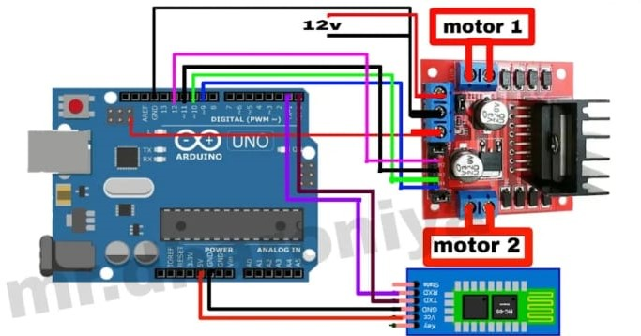

CONCLUSION :

Throughout the course of this project, we have explored the intricacies of embedded systems, wireless communication protocols, and mobile application development, gaining valuable insights into the integration of hardware and software components. From the construction of the physical car to the development of the control interface, each step has provided opportunities for learning, problem-solving, and creativity.

As we reflect on the journey of building the WiFi controlled car, we recognize its potential to inspire future innovations and applications in the realm of remote control systems. Whether used for educational purposes, home automation, or recreational activities, this project serves as a testament to the power of technology to enrich our lives and expand the boundaries of what is possible.

As we continue to embrace the advancements in connectivity and automation, let us remain inspired by projects like the WiFi controlled car, which remind us of the boundless opportunities that await us in the world of engineering and technology